SIMATS ENGINEERING
ASSESSMENT TOOL 1 — EXPERIMENTS
Name | Pattan shoib khan
Register Number | 192524299
Course Code | 0703
Course Name | Computer Networks
Course Outcome (CO3) | Analyze the performance of core network protocols such as TCP, UDP, HTTP, and DNS under varying conditions
Software Used | Cisco Packet Tracer, Wireshark
Total Marks | 40

Experiment 1: Simple LAN — Two PCs via Switch (Ethernet Frame Analysis)

Aim
To design a simple LAN with two PCs connected through a switch in Cisco Packet Tracer, verify connectivity using ping, capture the exchange in Wireshark, and analyze the Ethernet frame fields.

Topology
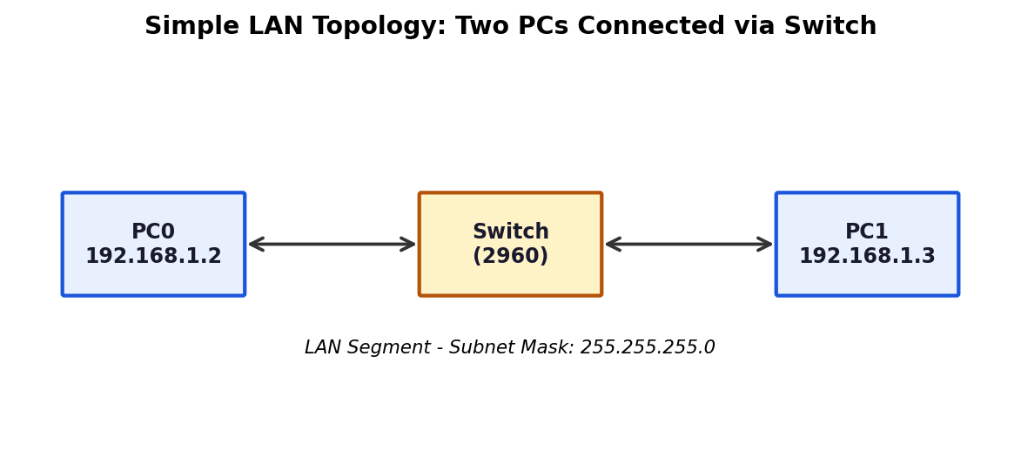
Fig 1.1 — PC0 and PC1 connected through a single Layer-2 switch

Procedure
- Place two PCs (PC0, PC1) and one 2960 Switch on the Packet Tracer workspace and connect them using straight-through copper cables.
- Assign IP addresses: PC0 = 192.168.1.2/24, PC1 = 192.168.1.3/24 (Desktop → IP Configuration).
- Wait until all link lights turn green, indicating the interfaces are up.
- Open the Command Prompt on PC0 and run: ping 192.168.1.3 to verify connectivity.
- Enable Wireshark / the Packet Tracer Simulation mode on the switch-facing link to capture the frame exchange during the ping.

Ethernet Frame Fields Observed
Field | Description | Sample Value
Destination MAC Address | Physical address of the receiving NIC | 0050.0002.BBBB
Source MAC Address | Physical address of the sending NIC | 0050.0001.AAAA
EtherType | Identifies the encapsulated upper-layer protocol | 0x0800 (IPv4)
Frame Check Sequence (FCS) | CRC value used to detect transmission errors | 32-bit CRC checksum

Analysis / Explanation
The Data Link layer uses MAC addressing so that frames can be delivered correctly within the same local network segment. When PC0 pings PC1, the switch examines the destination MAC address of each incoming frame and forwards it only out of the port associated with that address in its MAC address table (learned by inspecting source MAC addresses of prior frames). If the destination MAC is unknown, the switch floods the frame to all ports except the one it arrived on. The EtherType field tells the receiving NIC which Layer-3 protocol (here IPv4) to hand the payload to, while the FCS lets the receiver discard any frame that was corrupted in transit. This MAC-based, hardware-level addressing is what allows successful frame delivery on the local network without needing network-layer routing.

Conclusion
Connectivity between PC0 and PC1 was successfully verified using ping, and Wireshark analysis confirmed that Ethernet framing with MAC addressing, EtherType, and FCS ensures reliable frame delivery at the Data Link layer within a LAN.

Experiment 2: Two LANs via Router (IPv4 Header Analysis)

Aim
To construct two LANs connected through a router, configure IPv4 addressing/subnet masks/default gateways, verify end-to-end communication using ping, and analyze the IPv4 header fields captured in Wireshark.

Topology
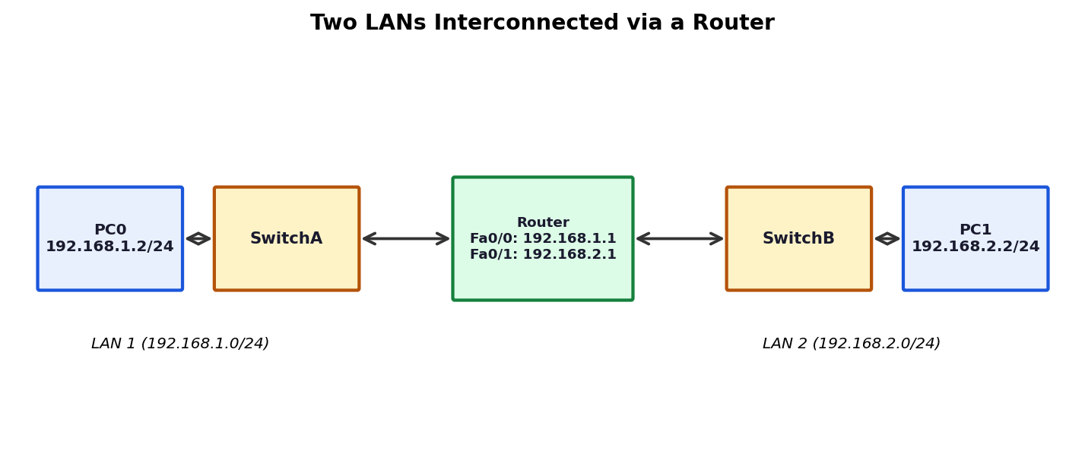
Fig 2.1 — PC0 (LAN1) and PC1 (LAN2) communicating through a router

Procedure
- Build the topology: PC0 — SwitchA — Router (Fa0/0) and Router (Fa0/1) — SwitchB — PC1.
- Configure Router Fa0/0 = 192.168.1.1/24 and Fa0/1 = 192.168.2.1/24; enable both interfaces (no shutdown).
- Configure PC0 = 192.168.1.2/24, gateway 192.168.1.1; PC1 = 192.168.2.2/24, gateway 192.168.2.1.
- From PC0, run ping 192.168.2.2 to test inter-network connectivity.
- Capture the ICMP packets on the router-facing links and open them in Wireshark/Simulation mode.

IPv4 Header Fields Observed
Field | Description | Sample Value
Source IP Address | Address of the originating host | 192.168.1.2
Destination IP Address | Address of the target host | 192.168.2.2
Time-To-Live (TTL) | Hop count limit; decremented by 1 at every router | 128 → 127 after routing
Protocol Number | Identifies the transport/upper-layer protocol carried | 1 (ICMP)
Header Length (IHL) | Length of the IPv4 header in 32-bit words | 20 bytes (no options)

Analysis / Explanation
The Network layer is responsible for logical addressing and forwarding packets between different networks. Because PC0 and PC1 are on different subnets, PC0 sends the ICMP packet to its default gateway (the router) rather than directly to PC1. The router examines the destination IP address, consults its routing table, decrements the TTL by one (to prevent packets from looping forever), and forwards the packet out the correct interface toward LAN 2. The Protocol field tells the receiving host's IP layer to hand the payload up to ICMP, and the Header Length field tells the parser where the IPv4 header ends and the payload begins. This routing behaviour — using IP addresses and TTL rather than MAC addresses alone — is what enables communication across different networks.

Conclusion
End-to-end connectivity between the two LANs was verified via ping, and the captured IPv4 headers confirmed the router correctly forwarded packets between subnets while decrementing TTL at each hop.

Experiment 3: ARP Resolution on a LAN

Aim
To construct a LAN with multiple hosts via a switch, clear the ARP cache on one host, ping another host, and capture/analyze the ARP Request and ARP Reply packets in Wireshark.

ARP Exchange
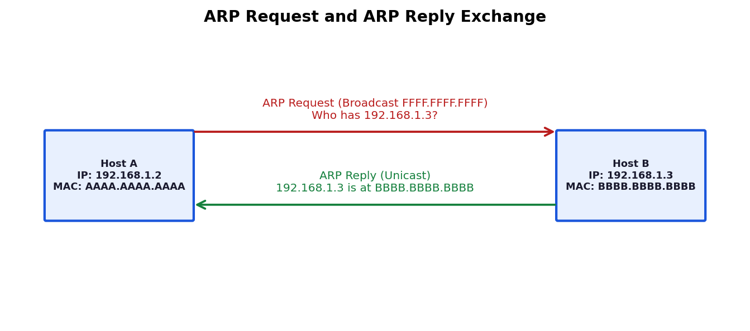
Fig 3.1 — Host A broadcasts an ARP Request; Host B unicasts the ARP Reply

Procedure
- Connect multiple PCs to a switch in Packet Tracer and assign each an IP address on the same subnet (e.g., 192.168.1.0/24).
- On Host A, open the command prompt and clear the ARP cache: arp -d.
- Run ping 192.168.1.3 (Host B) from Host A.
- Switch to Simulation mode / Wireshark and capture the packets exchanged before the ICMP echo.
- Identify the ARP Request (broadcast) and the ARP Reply (unicast) frames.

ARP Fields Observed
Field | ARP Request | ARP Reply
Sender MAC/IP | AAAA.AAAA.AAAA / 192.168.1.2 | BBBB.BBBB.BBBB / 192.168.1.3
Target MAC/IP | 00:00:00:00:00:00 (unknown) / 192.168.1.3 | AAAA.AAAA.AAAA / 192.168.1.2
Destination Address | FFFF.FFFF.FFFF (broadcast) | AAAA.AAAA.AAAA (unicast)
Opcode | 1 (Request) | 2 (Reply)

Analysis / Explanation
Since Host A's ARP cache was cleared, it does not know Host B's MAC address, so it cannot build an Ethernet frame directly. Host A broadcasts an ARP Request to the entire LAN asking 'Who has 192.168.1.3?', leaving the target MAC field blank. Every host on the segment receives this broadcast, but only Host B — whose IP matches the request — replies with a unicast ARP Reply containing its own MAC address. Host A then caches this IP-to-MAC mapping and uses it to address the subsequent ICMP Echo Request frame. This is exactly how ARP resolves logical (IP) addresses into physical (MAC) addresses so that Data Link layer delivery can take place.

Conclusion
The ARP Request/Reply exchange was successfully captured, confirming that ARP dynamically maps IP addresses to MAC addresses before any actual data transmission occurs on the LAN.

Experiment 4: ICMP Echo Request/Reply and RTT Calculation

Aim
To connect two PCs through a router, verify connectivity using ping, capture ICMP traffic in Wireshark, examine ICMP fields, and calculate the Round Trip Time (RTT).

ICMP Exchange
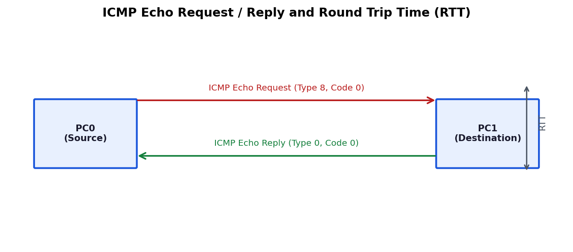
Fig 4.1 — ICMP Echo Request and Echo Reply with RTT measured at the source

Procedure
- Build a topology with PC0 and PC1 connected through a router, and configure IP addressing on both interfaces.
- From PC0's command prompt, run: ping 192.168.2.2 (PC1's address).
- Capture the traffic in Wireshark/Simulation mode and filter on icmp.
- Open an Echo Request and its matching Echo Reply frame and inspect the ICMP header fields.
- Note the timestamps of the request and reply to compute RTT = t(reply received) − t(request sent).

ICMP Fields Observed
Field | Echo Request | Echo Reply
Type | 8 | 0
Code | 0 | 0
Identifier | 0x0001 (matches request/reply pair) | 0x0001 (echoed back)
Sequence Number | Increments with each request (e.g., 1,2,3…) | Echoed back unchanged

RTT Calculation (Sample)
If the Echo Request is sent at t1 = 0.000 s and its Echo Reply is received at t2 = 0.002 s, then RTT = t2 − t1 = 2 ms. In Cisco Packet Tracer's ping output, this value is displayed directly for each of the four default probes, e.g., 'time<1ms', and the utility also reports the minimum, maximum, and average RTT across all probes sent.

Analysis / Explanation
ICMP (Internet Control Message Protocol) operates at the Network layer and is used to report errors and exchange diagnostic/control information rather than carry application data. The Type and Code fields together identify the specific ICMP message (Type 8/Code 0 = Echo Request, Type 0/Code 0 = Echo Reply). The Identifier and Sequence Number let the sending host match each reply to the request that triggered it, which is essential when multiple pings are in flight simultaneously. By timing how long a round trip takes, ping (built on ICMP) gives network administrators a simple, direct way to verify that a remote host is reachable and to estimate the latency of the path — making it one of the most widely used tools for connectivity verification and basic network troubleshooting.

Conclusion
The ICMP Echo Request/Reply exchange was successfully captured and analyzed, and the RTT was computed, demonstrating how ICMP supports reachability testing and latency measurement during network troubleshooting.

Experiment 5: Client–Server HTTP over TCP

Aim
To configure a web server and a client PC in Cisco Packet Tracer, access the hosted webpage via HTTP, and analyze the TCP three-way handshake followed by the HTTP GET/response in Wireshark.

TCP Handshake and HTTP Exchange
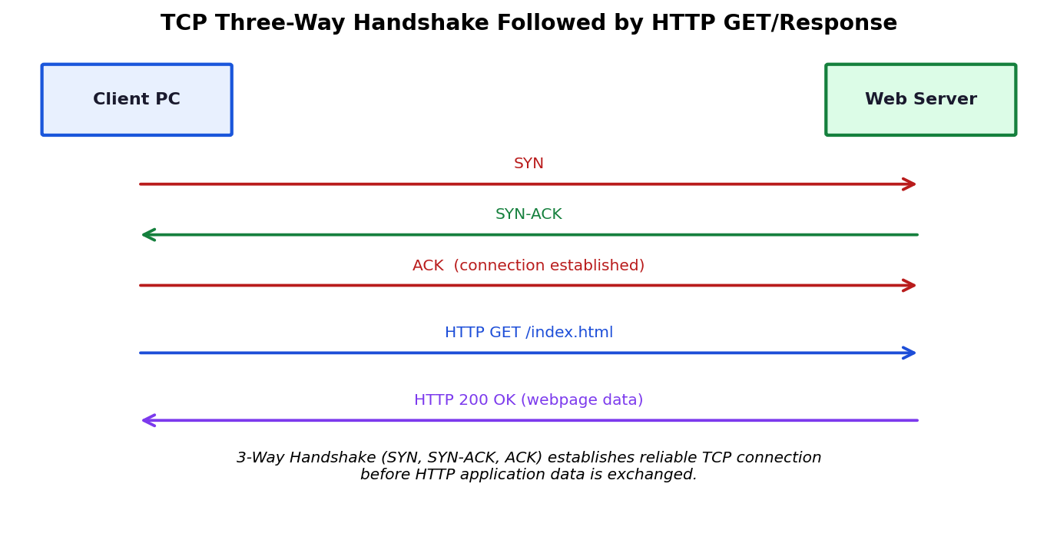
Fig 5.1 — TCP three-way handshake followed by HTTP GET and HTTP 200 OK response

Procedure
- Add a Server device, enable its HTTP service (Services tab → HTTP → On), and give it an IP address (e.g., 192.168.1.10/24).
- Add a Client PC on the same/routed network and configure its IP addressing.
- On the client, open the Web Browser (Desktop → Web Browser) and enter the server's IP address as the URL.
- Switch to Simulation mode and step through the events, or capture with Wireshark, filtering on tcp || http.
- Identify the SYN, SYN-ACK, and ACK segments, followed by the HTTP GET request and the HTTP response.

Key Fields / Messages Observed
Step | Message | Purpose
1 | TCP SYN (client → server) | Client requests connection, proposes initial sequence number
2 | TCP SYN-ACK (server → client) | Server acknowledges and proposes its own sequence number
3 | TCP ACK (client → server) | Client acknowledges; connection is now established
4 | HTTP GET /index.html | Client requests the webpage over the established TCP connection
5 | HTTP 200 OK | Server returns the requested HTML content

Analysis / Explanation
TCP provides reliable delivery to HTTP through connection establishment, acknowledgment, and ordered data transfer. Before any HTTP data is sent, the client and server perform a three-way handshake (SYN → SYN-ACK → ACK) to synchronize sequence numbers and confirm that both ends are ready to communicate. Once the connection is established, the HTTP GET request and the server's response are broken into TCP segments, each carrying a sequence number; the receiver uses these numbers to reassemble the data in the correct order and sends acknowledgments (ACKs) for received segments, allowing the sender to detect and retransmit any lost segments. This combination of handshake, sequencing, and acknowledgment is what distinguishes TCP from a connectionless protocol like UDP, and it is why HTTP — which needs a complete, correctly-ordered web page — is built on top of TCP.

Conclusion
The client successfully retrieved the hosted webpage from the server, and Wireshark analysis confirmed the TCP three-way handshake preceding the HTTP GET/response exchange, illustrating how TCP guarantees reliable delivery for application-layer HTTP traffic.

Rubrics Reference (Level 4 — Exemplary)
Criteria | Weightage | Level 4 – Exemplary Descriptor
Understanding of Concepts | 25 | Demonstrates thorough understanding and effectively integrates multiple concepts/technologies
Experimental Design | 30 | Well-planned, systematic implementation with optimal solution
Use of Tools | 20 | Effective and advanced use of tools/technologies with proper configuration
Analysis of Results | 15 | Insightful analysis with accurate interpretation and validation of results
Documentation | 10 | Clear, well-structured documentation with diagrams, code, and results

